Project Development

Implement Client Script & UI Policy (Incident) — ServiceNow

1. Overview
Incident records need consistent, accurate data for effective triage, routing, and resolution. Relying only on manual checks can lead to incomplete or incorrect data, which hurts reporting accuracy and SLA compliance. This project enforces conditional field behavior and validation at the UI level using ServiceNow UI Policies and Client Scripts, so Incident records meet business rules before they are submitted.

2. Objective
Demonstrate how client-side controls (UI Policies and Client Scripts) can dynamically make fields mandatory, auto-populate values, control field behavior, and block submission when required conditions aren't met — improving data quality and consistency on the Incident table.

3. Skills Used
- Incident Management
- UI Policy & UI Policy Actions
- Client Scripts (onChange, onSubmit, onCellEdit)
- Form Validation

4. Implementation Summary

Task 1 – UI Policy: High Impact Control
Created a UI Policy named "High Impact Control" on the Incident table, triggered when Impact = 1 - High. "Reverse if false" is enabled, so field changes revert automatically when the condition is no longer true.
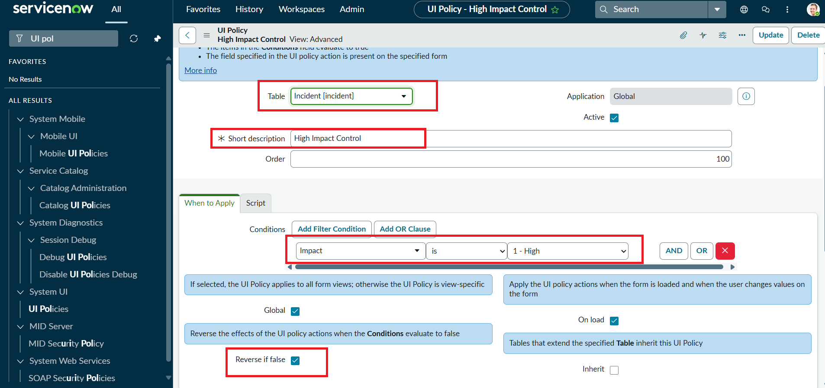
UI Policy condition: Impact is 1 - High, with Reverse if false enabled

Task 2 – UI Policy Actions: Assignment Group & Urgency
Two UI Policy Actions were added to the policy: Assignment Group is made mandatory, and Urgency is made read-only, whenever the condition (Impact = High) is met.
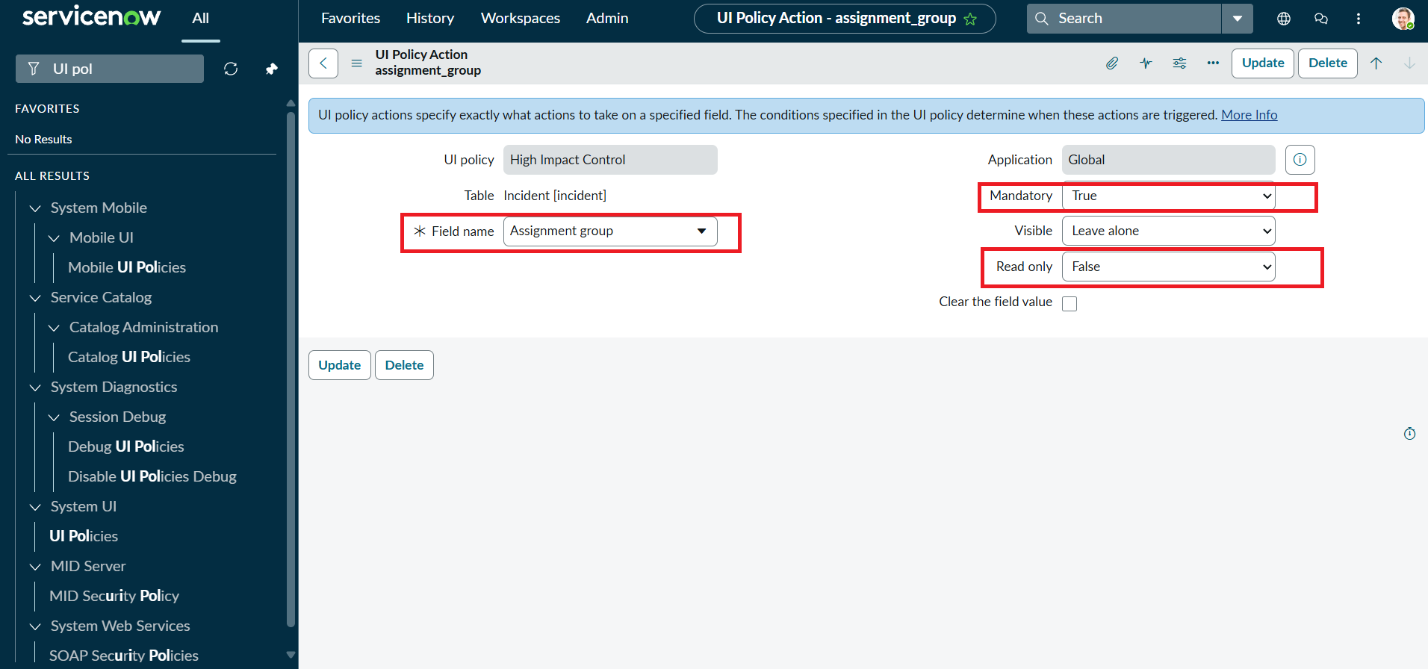
UI Policy Action — Assignment group set to Mandatory: True
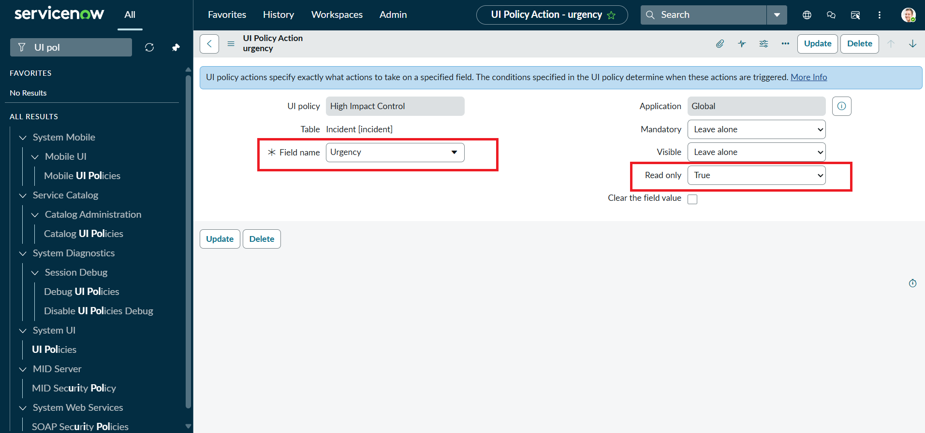
UI Policy Action — Urgency set to Read only: True

Task 3 – onChange Client Script: Auto-set Urgency
An onChange script on the Impact field automatically sets Urgency to High when Impact is set to High, and shows an informational message to the user.
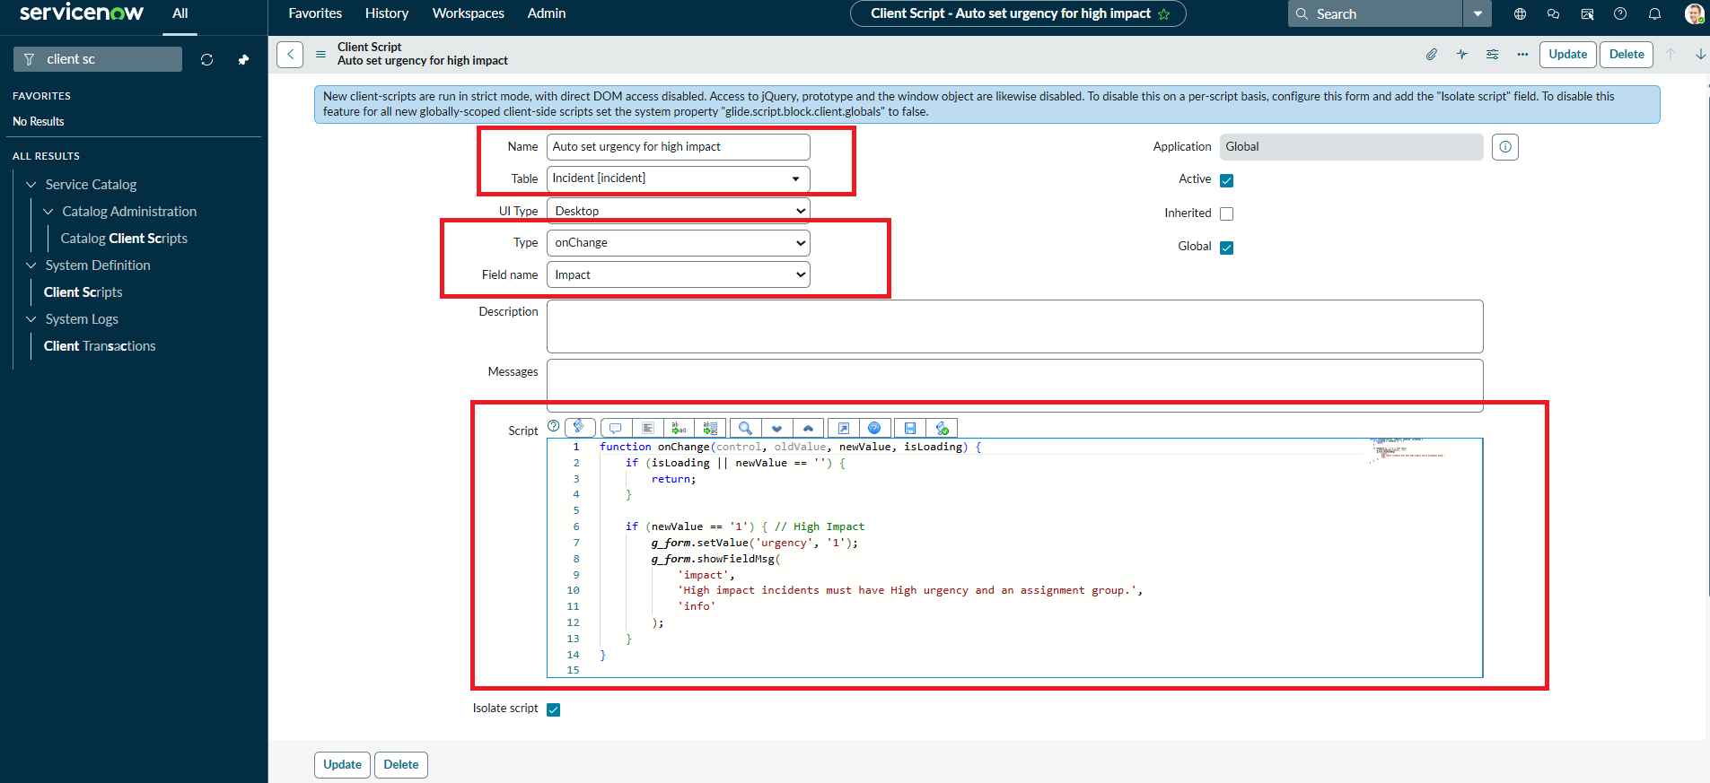
onChange script auto-setting Urgency for High impact incidents

Task 4 – onSubmit Client Script: Save Validation
An onSubmit script blocks the save when Impact is High and Assigned To is empty, showing an inline error on the field.
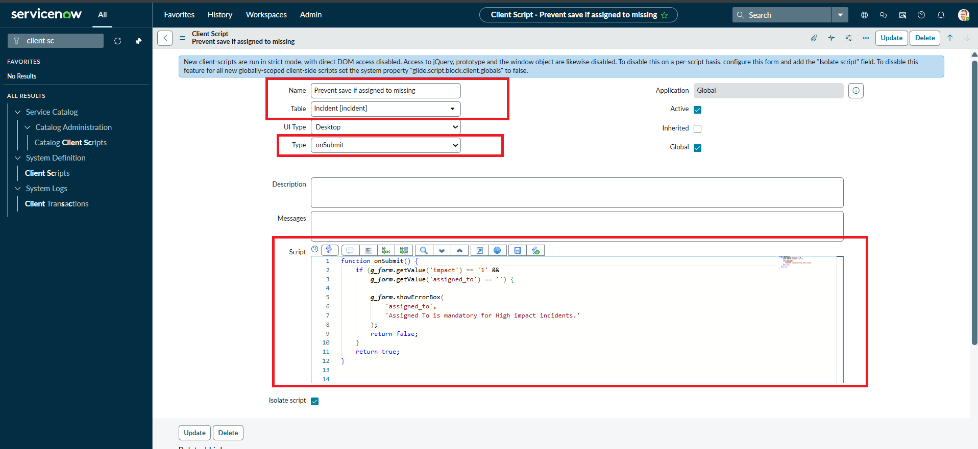
onSubmit script requiring Assigned To for High impact incidents

Task 5 – onCellEdit Client Script: Protect State in List View
An onCellEdit script blocks inline edits to the State field from the Incident list view, prompting the user to open the record instead.
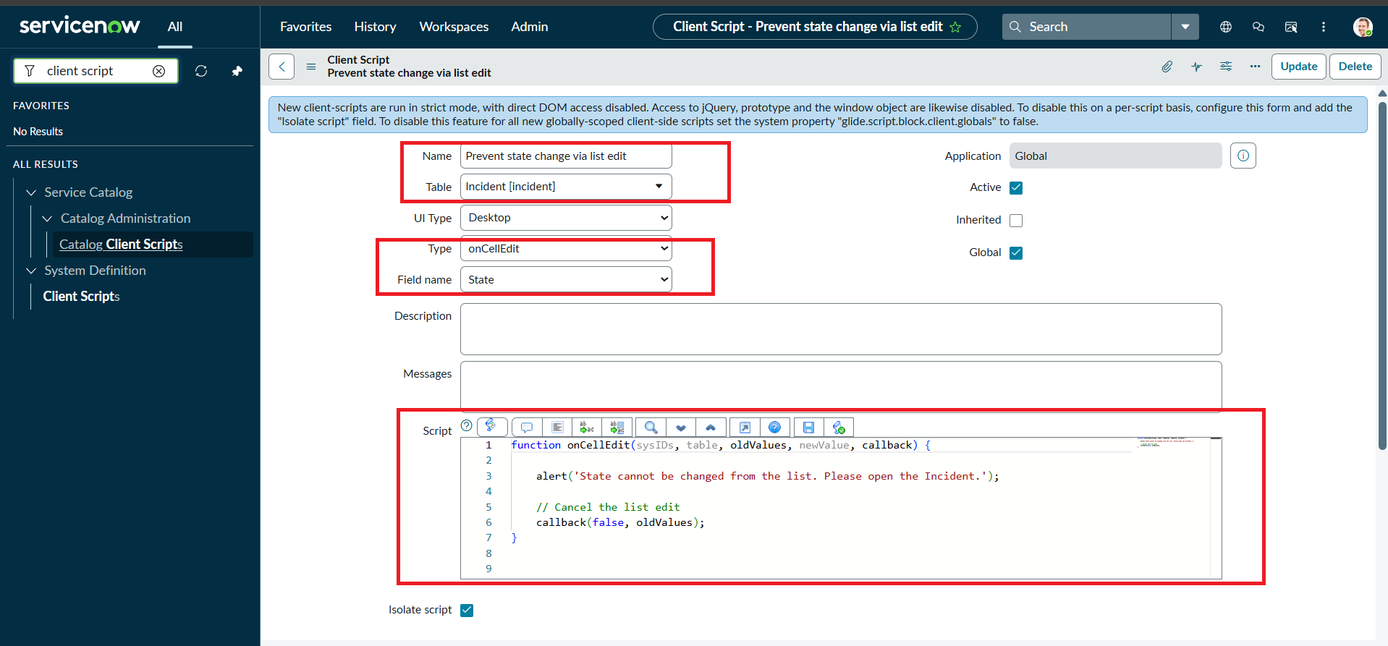
onCellEdit script preventing State changes from list editing

5. Testing & Results

Mandatory field enforcement
Setting Impact to High with Assigned To empty blocks the save and shows an error.
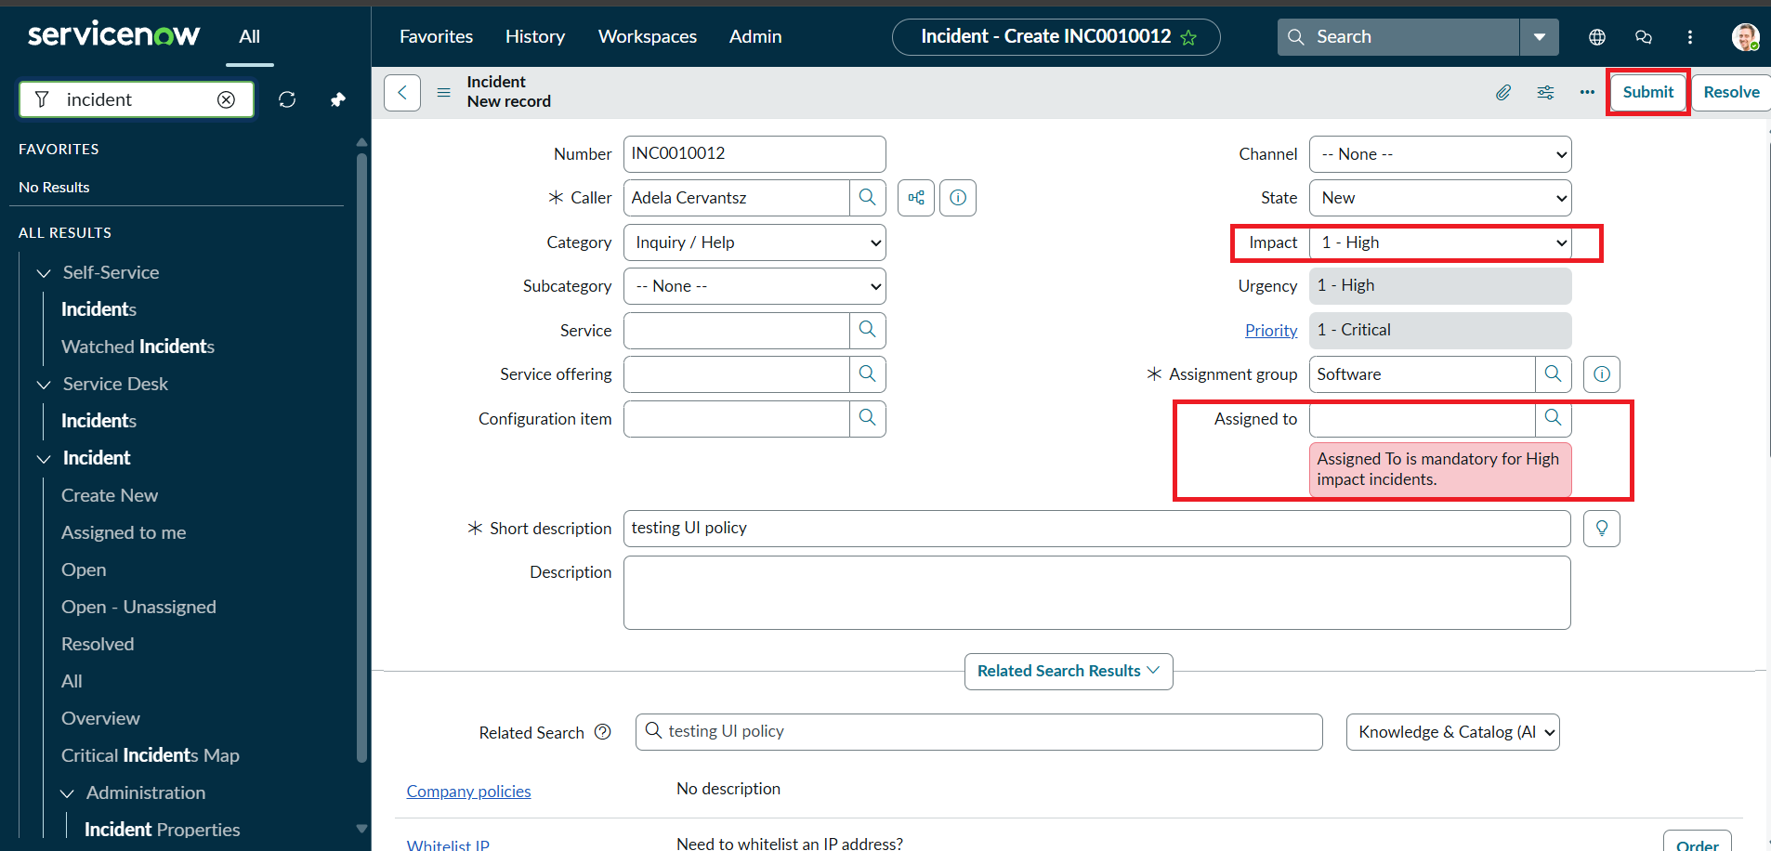
Save blocked: "Assigned To is mandatory for High impact incidents."

Successful save
Once Assigned To is filled in, the record saves successfully; Urgency remains read-only as configured.
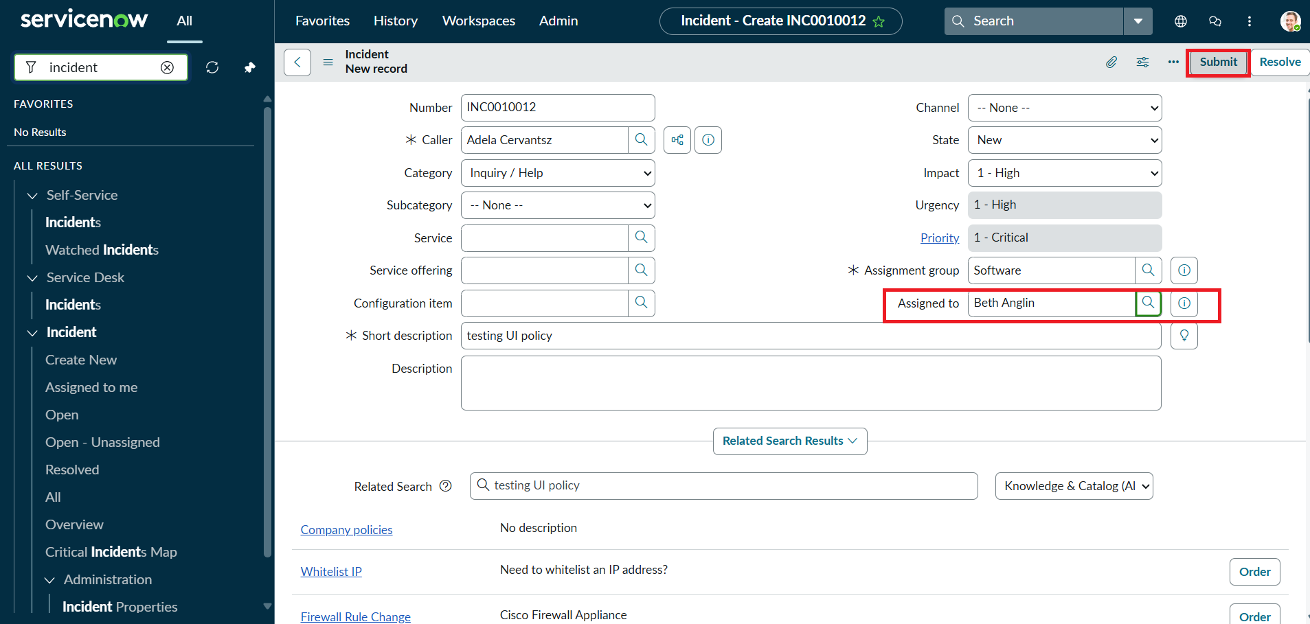
Incident saved successfully with Assigned To completed

Reverse condition
Changing Impact back to Medium reverses the policy effects — Assigned To is no longer mandatory and Urgency becomes editable again.
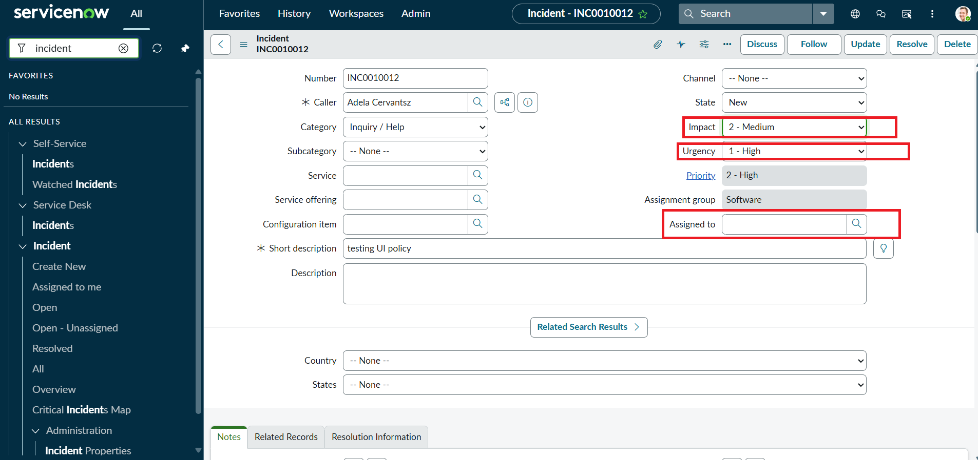
Impact changed to Medium — Urgency editable, Assigned To no longer required

List edit blocking
Attempting to edit the State field directly from the Incident list triggers a warning and the change is blocked.
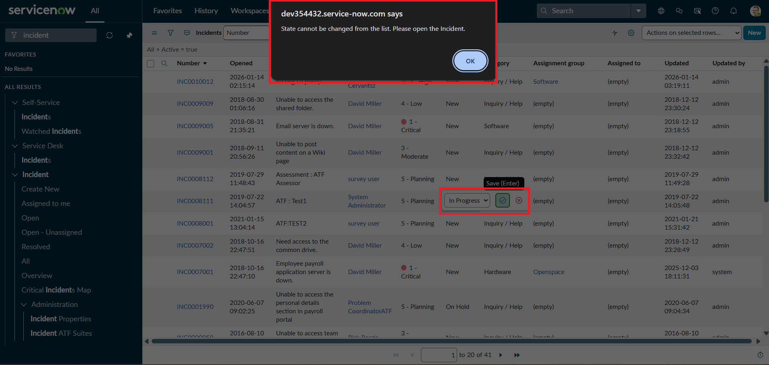
Alert: "State cannot be changed from the list. Please open the Incident."

6. Conclusion
This project shows how UI Policies and Client Scripts work together to enforce dynamic field behavior, automate updates, and prevent incorrect data submission on Incident forms. Using onChange, onSubmit, and onCellEdit scripts alongside UI Policy actions keeps fields like Assigned To and Urgency consistent with changes in Impact — a lightweight, practical approach to improving data integrity in ServiceNow.

